Updating Tax Tables Checklist
The tax tables need to be updated in Human Resources BEFORE your January 2021 payroll. Download the two tax tables from our email or website, then complete the following:
_____ In TxEIS, go to Human Resources > Utilities > Install Salary/Tax Tables. Select Fed. Income Exempt, type 2021 in the Calendar Year.
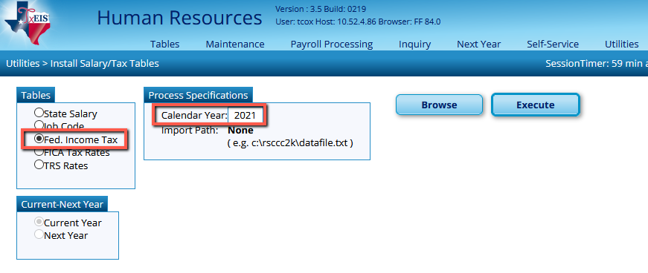
Browse to the 2021_Fed_Income_Tax.txt file on your computer. Click Submit, then click Execute.
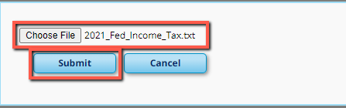

At the preview, select Process.

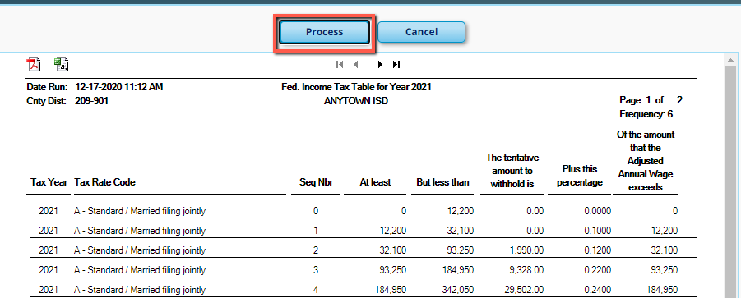

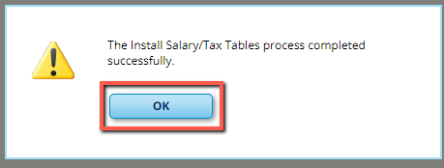

_____ Repeat the same process for the FICA tax file.
Select the radio button for FICA Tax Rates.
Browse: Select the radio button FICA Tax Rates and the file named 2021_FICA_Tax_Rates.txt.
Select Execute
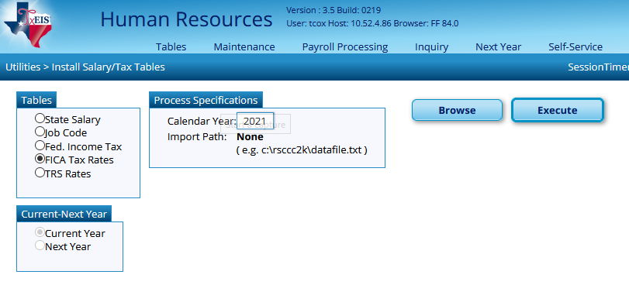
Select Process at the Preview.



